**SL Unit 4** **– Problem Solving**  
Quiz 4

|  |  |  |  |
| --- | --- | --- | --- |
| **Question 1** | | | |
| Objectives: | 4.2.4 | Exam Reference: | Nov-16 6 |

1. Consider the following algorithm that inputs X and N, and outputs P.

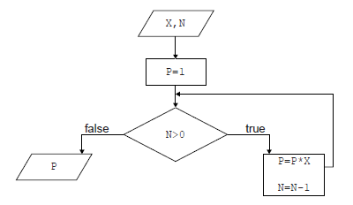

1. Determine how many times multiplication is performed when this algorithm is executed. [1]
2. Construct a trace table for the algorithm when X=2 and N=4. Use the following

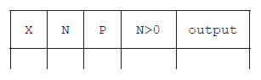headings in your table.   
  
  
  
  
  
 [4]

1. State the purpose of this algorithm. [1]

|  |  |  |  |
| --- | --- | --- | --- |
| **Question 2** | | | |
| Objectives: | 4.2.1, 4.2.7 | Exam Reference: | May-15 10 |

1. (a) Identify **two** differences and **two** similarities between a bubble sort and a selection sort

when sorting an array of 10 elements. [4]

A cycling tour lasts for 15 days. The total time for each competitor is recorded in a

one-dimensional array, TIMES[]. After each day’s race, the array entry for each competitor

is increased by their time for that day.

There are 150 competitors and the 10 fastest times are transferred to the array FASTEST[]

and displayed on a screen each day.

1. Explain why a selection sort would be more efficient than a bubble sort in this case. [2]
2. Construct an algorithm to transfer the 10 fastest times from the array TIMES[] to the

array FASTEST[]. Assume that the array TIMES[] is not sorted. [6]

The race organizers need to display the names of the 10 fastest competitors, as well as  
their times, on the screen. There is another array, NAMES[], which contains the names of  
all competitors in the same order as their times in TIMES[] (for example, NAMES[5] and  
TIMES[5] are the name and time of the same competitor).

1. Compare the use of two arrays, to hold the competitor’s times and names, with the use

of objects. [3]

|  |  |  |  |
| --- | --- | --- | --- |
| **Question 3** | | | |
| Objectives: | 4.1.16 | Exam Reference: | May-15 7 |

Six students are planning their group 4 project, which is due in two days. They have to  
produce a scientific report and give an animated computer presentation based on their  
analysis of water samples. These water samples are to be taken from four local lakes.

1. Based on this information, identify **four** tasks that should be done by the students,  
   listing the tasks in the order that they could be completed. [2]

1. Outline how **two** of the tasks identified in part (a) could be completed concurrently. [2]
2. Draw a Gantt chart to show the tasks from part (a), indicating the concurrency outlined  
   in part (b). You do not need to include the timings for the tasks. [2]

|  |  |  |  |
| --- | --- | --- | --- |
| **Question 4** | | | |
| Objectives: | 4.3.4 | Exam Reference: | May-17 10 |

Other than the use of different keywords, outline two ways in which two higher level   
languages might differ from one another. [4]